**WEKA OUTPUTS:**

* **On using Naïve Bayes Classification, we find out that the Currently classified instances or the accuracy comes out to be 88.94% as seen in the figure.**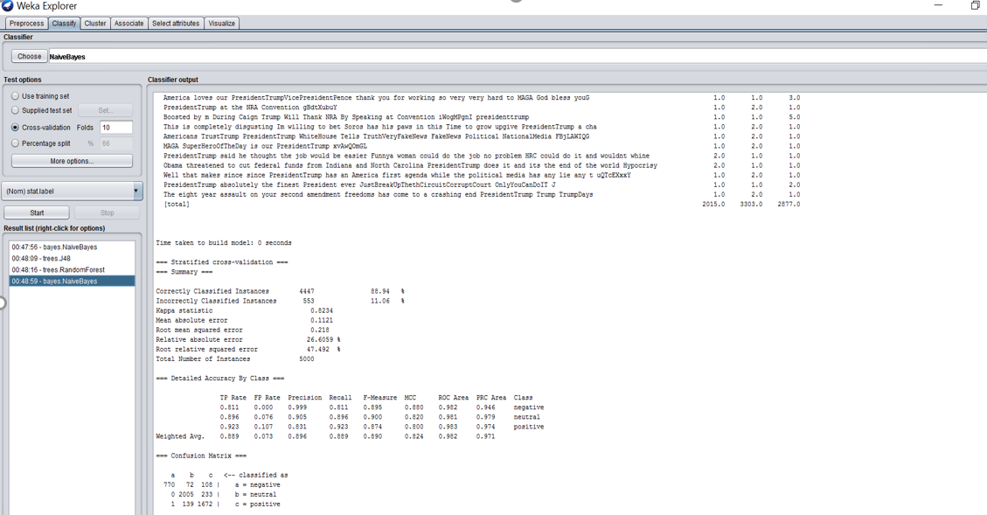
* **J-48 Classifier Accuracy=89.7%**

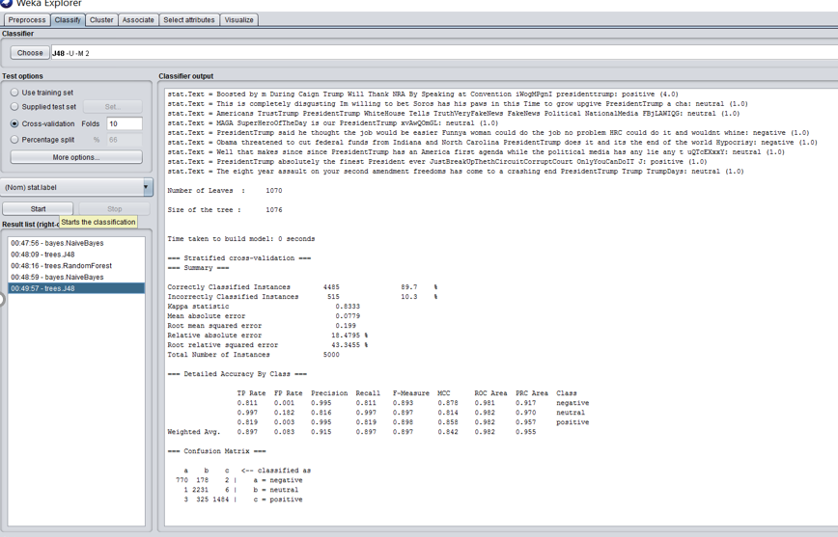

* **Random Forest shows Accuracy=89.8%**

